**Software Requirement Specification for**

**Online Voting System for college**



**Submitted to Submitted by**

Divyadeep Bhatnagar Sopnil Golay Tamang

Acadview 1611981377

**INDEX**

________________________________________________Page No.

1. Introduction.……………………………………………………………………………………………………03
2. Objective….……………………………………………………………………………………………………..03
3. Project Category.…….……………………………………………………………………………………….03
4. Technology Used …………………………………………………………………………………………….04
5. Software Requirement.……………………………………………………………………………………04
6. Hardware Requirement ………………………………………………………………………………….04
7. Feasibility Study ……….…………………………………………………………………………………….04
8. Design……………………………………………………………………………………………………………..05
9. Project planning………………………………………………………………………………………………06
10. Testing…………………………………………………………………………………………………………….07
11. Implementation of security mechanism at various levels………………………………..09
12. Future scope and enhancement ……………………………………………………………………..10
13. Bibliography…………………………………………………………………………………………………….10
14. INTRODUCTION

“Online voting system for college” is a web-based project which is made for making official decision within the college for official position within the college. Nowadays in large organization, taking official decision are being harder due lots of working staffs in within an organization and paper voting system is being time consuming and also being unreliable. So as technology are being advanced nowadays, We are planning to build a web based app for Voting to take decision within the organization in faster, reliable and secure way without wasting any resources and employees. User of the organization just have to fill the form and show they valid employee within organization using user id and give their personal information to register, and you are ready!!!

This project entitled “**Voting system in college**” is an implementation of the above description. It implements the E-voting system (Electronic voting system). It lets users to make their decision for organization in a secure way.

1. OBJECTIVE

There are several objectives of this websites are following given below:

* This site will give all the details of candidates so that voters can get better understanding of candidates.
* It will value privacy of voters for leaking voting information unlike paper voting system.
* It can count and publish votes in seconds of time which make work faster.
* This Online voting app will be reusable and so that we don’t have to waste our resources and manpower unlike paper voting system.

1. PROJECT CATEGORY

Web based java application using Html, CSS and MySQL as back end.

1. TECHNOLOGY USED

* It is a web-based application with **java 8** as server-side scripting language and **MySQL 8.0** as the DBMS. Clients will be Google Chrome, Mozilla Firefox, and Microsoft based.
* All front-end design is done using Html5, Cascading style sheets(CSS) and JavaScript.

1. SOFTWARE REQUIREMENTS

* Glassfish Server
* NetBeans IDE (8.2)
* Browser (Google Chrome, Mozilla Firefox)

1. HARDWARE REQUIREMENTS

* Intel Duel Core 2.0GHz or higher processor
* 2 GB RAM
* 10 GB HDD Space

1. FEASIBILITY STUDY

The main aim of the feasibility study activity is to determine whether it would be financially and technically feasible to develop the project. It involves analysis of the problem and collection of all relevant information.

After collecting all the relevant information (like who are the users, how they interact with the system etc) and details about our project “Online Voting System in College” we reach at the conclusion that the system is financially feasible and can be developed using the technology that we presently have.

1. DESIGN

System Design is a detailed study of various operations performed by a system and its relationships within and outside the system. The commonly used tools for analysis are DFD (the logical representation of the analysed system), ERD, onsite observations etc.

**Data Flow Diagrams (DFD)**

A data flow diagram (DFD) is a graphical representation of the "flow" of data through an information system, modeling its process aspects. A DFD is often used as a preliminary step

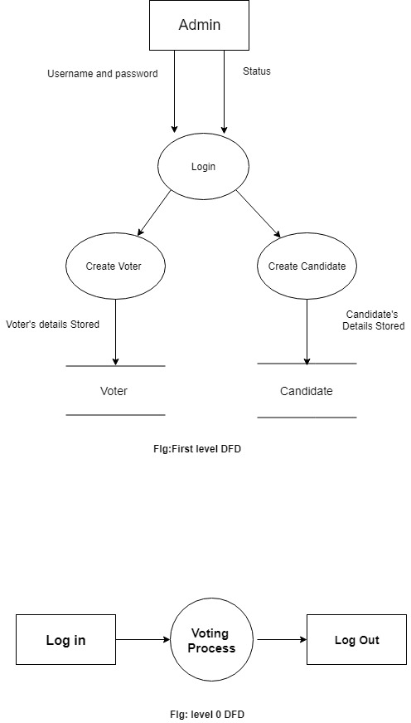

to create an overview of the system without going into great detail, which can later be elaborated. DFDs can also be used for the visualization of data processing (structured design).

**Entity Relationship Diagram (ERD)**

An entity-relationship diagram (ERD) is a data modeling technique that graphically illustrates an information system’s entities and the relationships between those entities. An ERD is a conceptual and representational model of data used to represent the entity framework infrastructure. The elements of an ERD are:

* Entities
* Relationships
* Attributes

Steps involved in creating an ERD include:

1. Identifying and defining the entities
2. Determining all interactions between the entities
3. Analyzing the nature of interactions/determining the cardinality of the relationships
4. Creating the ERD

**The Relational Schema of the developing system is shown below:**

1. **Employee** (Uid, Uname, password, Phone_no, Address)
2. **Candidate**(Uid , UName, details, image)
3. **brand**(brand_id, brand_name)
4. **feedback(**fid, Uname, subject, comments)
5. **admin**( admin_id, name, password)
6. PROJECT PLANNING AND SCHEDULING

The development time including database design, screen designing and coding and testing is one month. First two months the screen, database design and system design will be over. Second and third month is for developing modules, architecture design and coding the site. Rest will be for testing and error correction.

|  |  |  |  |
| --- | --- | --- | --- |
|  | **1-2 Week** | **2-3 Week** | **3-4 Week** |
| Requirement Gathering |  |  |  |
| Design |  |  |  |
| Test cases |  |  |  |
| Coding |  |  |  |
| Quality Assurance |  |  |  |
| Testing |  |  |  |
| Build |  |  |  |

1. TESTING

Software testing is the process of evaluation a software item to detect differences between given input and expected output. Also to assess the feature of A software item. Testing assesses the quality of the product. Software testing is a process that should be done during the development process. In other words software testing is a verification and validation process.

***Verification***

Verification is the process to make sure the product satisfies the conditions imposed at the start of the development phase. In other words, to make sure the product behaves the way we want it to.

***Validation***

Validation is the process to make sure the product satisfies the specified requirements at the end of the development phase. In other words, to make sure the product is built as per customer requirements.

***Basics of software testing***

There are two basics of software testing: blackbox testing and whitebox testing.

**Blackbox Testing**

Black box testing is a testing technique that ignores the internal mechanism of the system and focuses on the output generated against any input and execution of the system. It is also called functional testing.

**Whitebox Testing**

White box testing is a testing technique that takes into account the internal mechanism of a system. It is also called structural testing and glass box testing.

Black box testing is often used for validation and white box testing is often used for verification.

***Types of testing***

There are many types of testing like

* Unit Testing
* Integration Testing
* Functional Testing
* System Testing
* Stress Testing
* Performance Testing
* Usability Testing
* Acceptance Testing
* Regression Testing
* Beta Testing

Unit Testing

Unit testing is the testing of an individual unit or group of related units. It falls under the class of white box testing. It is often done by the programmer to test that the unit he/she

has implemented is producing expected output against given input.

Integration Testing

Integration testing is testing in which a group of components are combined to produce output. Also, the interaction between software and hardware is tested in integration testing if software and hardware components have any relation. It may fall under both white box testing and black box testing.

Functional Testing

Functional testing is the testing to ensure that the specified functionality required in the system requirements works. It falls under the class of black box testing.

System Testing

System testing is the testing to ensure that by putting the software in different environments (e.g., Operating Systems) it still works. System testing is done with full system implementation and environment. It falls under the class of black box testing.

Stress Testing

Stress testing is the testing to evaluate how system behaves under unfavorable conditions. Testing is conducted at beyond limits of the specifications. It falls under the class of black box testing.

Performance Testing

Performance testing is the testing to assess the speed and effectiveness of the system and to make sure it is generating results within a specified time as in performance requirements. It falls under the class of black box testing.

Usability Testing

Usability testing is performed to the perspective of the client, to evaluate how the GUI is user-friendly? How easily can the client learn? After learning how to use, how proficiently can the client perform? How pleasing is it to use its design? This falls under the class of black box testing.

Acceptance Testing

Acceptance testing is often done by the customer to ensure that the delivered product meets the requirements and works as the customer expected. It falls under the class of black box testing.

Regression Testing

Regression testing is the testing after modification of a system, component, or a group of related units to ensure that the modification is working correctly and is not damaging or imposing other modules to produce unexpected results. It falls under the class of black box testing.

Beta Testing

Beta testing is the testing which is done by end users, a team outside development, or publicly releasing full perversion of the product which is known as beta version. The aim of beta testing is to cover unexpected errors. It falls under the class of black box testing.

1. IMPLEMENTATION OF SECURITY MECHANISM AT VARIOUS LEVELS

The modules data is stored in the database. It can be accessed only by user who is having access permission. Access control module also gives security to all application modules. This module is for administrative purpose for giving task level permission to users of the Application.

Security refers to the protection of data against unauthorized access, alteration, or destruction. Security measures are applied to the proposed system at different levels. There are two type of access to the system, one for administrative purposes and other for the client activities. It provides high security because a client can modify only permitted areas. Primary Key validation is used in this project. Password protection is provided at the application level, so that the unauthorized users have no access to the application.

1. FUTURE SCOPE AND ENHANCEMENT

This software will help to reduce manual effort and time. It also provides security. The proposed system is user-friendly and every aspects of this system can be easily understood and the user can operate the system easily. We have planned to develop this software as independent in nature and cost effective. As the saying goes “There is always scope for the improvement in every system”, even this system could be improved at various stages.

* To combine official website with this voting website.
* We can create a web voting android app for compatibility.

1. BIBLOGRAPHY

* Head First Java & MySQL: by Bert Bates, Kathy Sierra and Michael Morrison.
* Database Management System by L. Mathu Krithiga Venkatesh.
* Database Analysis and Design by Igor Hawryszkiewycz .